Modern open-source, cloud-native, serverless web-mapping:  
A Case Study for the Agriculture Industry

**Database Design**

**\***Supported by the AWS Cloud Credits for Research program

Amy Farley

GEOG 868|Summer 2020|Final Project

Table of Contents

Project Background 1

Project Purpose 2

Project Criteria 3

Spatial Reference System 3

Data Specifications 4

User Interface (UI) Considerations 5

UI Mockups 5

Database Design 13

Entity-Relationship (ER) Diagram 15

Explanation 16

Main Entity Tables and Junction Tables 18

Lookup tables 20

History Tables 20

Indexing 23

Attribute Indexing 23

Spatial Indexing 23

JSONB Indexing 23

Required Queries 23

Sample Data INSERT Statements 24

Sample Geometry INSERT Statements 24

Sample Geometry SELECT Statements 29

Sample JSON SQL 31

Encrypted Fields 32

Future Considerations 32

Conclusion 33

References 35

# Project Background

Earlier this year, I presented research for the [MGIS capstone project](http://personal.psu.edu/alf33/). The project proposed is a geospatial data management and visualization tool to make sense of all the geospatial data inundating the agriculture industry.

Data in the agriculture industry is coming from a variety of sources including satellite and drone imagery, GPS sensors on farm equipment, field and weather sensors collecting moisture and temperature information, soil samples, and visual observations.

This is an intimidating amount of data for an individual grower. For an agriculture consultant, growers’ association, or agriculture retailer managing multiple growers’ fields, this amount increases exponentially. This creates a need for a robust, scalable management solution.

Aside from the sheer volume of data being generated, additional trends in the agriculture industry contribute to the need for a data management solution. Commodity prices continue to drop causing cost containment to become a major concern in the industry. Customer demand for transparency in food production is also driving the need for ways to manage and share data related to food production between growers and consumers. ***The focus of the MGIS capstone project is specifically on crop growers and organizations that access and/or manage field data for growers such as farm managers, agriculture retailers, grower associations, crop consultants, and agronomists.*** (Farley A. , 2020)

As a software developer with experience building web applications using open-source technologies and experience in cloud computing, the MGIS capstone research recognizes an opportunity to create a data management solution that is affordable, customizable, and delegates ownership of the code and data to the end-user. The agriculture industry is experiencing a period where existing solutions are proprietary, expensive, overly broad, or very specific.

The capstone project objective is to take advantage of modern cloud computing architecture, open-source technology, and industry-standard web-mapping solutions to build an open-source solution on the cloud-computing platform Amazon Web Services (AWS).

Specifically, the project objective is to build the solution using “serverless” architecture. In order to truly take advantage of the scalability benefits of cloud computing, the solution will be built **without** provisioning virtual machines in the cloud computing platform. Instead, only readily-available services provided by the cloud computing provider will be used to store, retrieve, update, and display the geospatial and attribute data in a web-mapping interface.

In short, the idea is to push the needle in terms of how web-mapping applications are built. As technology continues to accelerate, there is a convergence of industry trends and technology advancements that can be combined to create solutions for geospatial data management and visualization that are more accessible, affordable, scalable, configurable, and, most importantly, valuable.

# Project Purpose

The purpose of this project addresses a specific component of the capstone project web-mapping solution. Figure 1 is an illustration included in the MGIS capstone research presentation. It shows the AWS services required for a “serverless” application with open-source technology choices overlaid on the services.

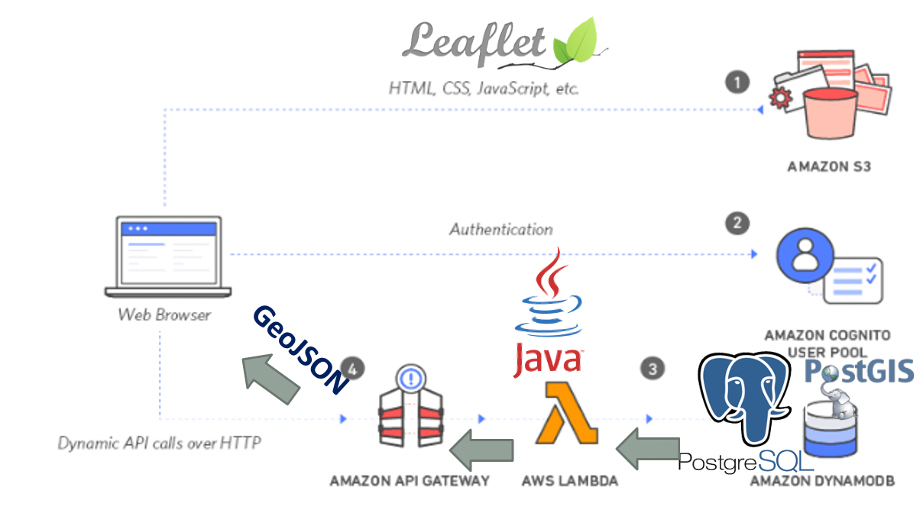  
**Figure 1.** AWS Serverless Architecture with open-source technology choices  
© 2020 Amazon Web Services . © 2010–2019 Vladimir Agafonkin.. © OpenStreetMap contributor. © 2020 Oracle

© 1996-2020 The PostgreSQL Global Development Group. © PostGIS Project Steering Committee.

Reproduced here for educational purposes only.

The circled items in Figure 1 are addressed in this project. At the heart of any application is data. This project presents the database design required for the project. The project addresses the design from two perspectives. One perspective is simply the specifics about the data being generated in the agriculture industry. The other perspective is from the web-mapping interface where users will view, search, update, and add geospatial, attribute, and file data records.

Along with the database design, this project identifies specific data queries required to deliver and store the data between the web-mapping interface and the relational database management system (RDBMS). Due to the nature of the “serverless” architecture, consideration for how to format the data that will be passed between the web-mapping interface and the RDBMS by way of AWS Lambda functions is addressed in the RDBMS-specific function selections.

# Project Criteria

## Spatial Reference System

As with any project that involves geospatial data, careful thought has been given to the spatial reference systems needed for the project After research, two spatial reference identification (SRID) European Petroleum Survey Group (EPSG) numbers will be used for the overall solution.

* EPSG:4326
* EPSG:3857

EPSG:4326 is a geographic coordinate system that is recognized as the most common SRID for storing geospatial data. (Ramsey & Leslie, 2012) (Frazier, 2020) (Esri, 2020) Another reason for using EPSG:4326 over EPSG:4269, which is common in the United States, is because Google uses WGS84 (EPSG:4326) for the Keyhole Markup Language (KML) files generated from Google Earth. (Google, 2020) Capstone research revealed that Google Earth is already being used by some in the agriculture industry to create field boundary files. (Farley J. , 2020) (Whitney, 2019) The geographic data in the KML files will ultimately be imported into geometry fields in the database. For these reasons, the data will be stored in the database using EPSG:4326.

EPSG:3857 also known as Web Mercator projection is a projected coordinate system widely used for web-mapping applications. (Esri, 2020) (Wikipedia contributors, 2020) Data will be transformed to this SRID for

display on the web-mapping interface.

## Data Specifications

**Data will be organized around agricultural fields.** Data in the agriculture industry comes in a wide variety of formats. To begin, field boundaries are vector data. Field access points are vector data. Other data could be raster format or contain no geographic information at all.

Fields are subject to constant “activity” such as planting, harvesting, soil sample collections, satellite and drone observations, fertilizer applications, moisture and temperature updates, and visual observations. This activity data comes in a range of formats. There could be a geographic point (vector) associated with the activity in some cases. The activity data may also include raster data such as georeferenced imagery. The activity data could even include non-geospatial documents or image files. The activity data could be owned by the field management team and stored in an Amazon S3 bucket as part of the overall field management solution. The activity data could also only be accessible through a third-party vendor platform such as DroneDeploy or MyJohnDeere. (Whitney, 2019) (Farley J. , 2020)

Vector data will be stored in the database. All raster and non-geospatial document and image files will be stored outside of the database and be accessible via a web address.

All the data has an important temporal component. Dates are important for all field activities. Besides field activity, as field boundaries and/or field properties change, history must be recorded with change dates.

Fields have associated users such as growers and landowners. Fields can have one or more of these associations. These associations may change over time.

Along with all the field activities, field users, and field history, fields will have attributes that will change over time. Each field may have its own unique set of attributes. The list of attributes can change over time as demand for information changes. Field attributes could include information such as crops grown, type of irrigation system, and type of pest control.

It is important to note here that certain field properties such as growers and owners are recognized as universal and eternal. The values of these properties can change, but each field entity will have these properties for identification purposes. Other properties are recognized as dynamic. The dynamic properties are referred to as the field attributes and handled differently in the database design. The design must accommodate each field having a unique set of field attributes.

## User Interface (UI) Considerations

The UI will be built out in phases. The MGIS capstone research proposal listed basic functionality required in the initial version of the web-mapping application. This functionality list is as follows:

* + User interface must retrieve geospatial data and add/update geospatial data
  + User interface must include functionality to query data spatially and by attributes
  + User interface must include functionality to add/update attribute data

To be more specific, the initial version must allow for displaying, editing, and adding field boundaries. Users must be able to query by both spatial and non-geospatial data associated with a field. Users must be able to edit non-geospatial data associated with a field. Users must be able to add field activity data. Users must be able to view field activity data and upload any files associated with the field activity.

Phase 1 of the UI assumes only administrative users will be using the web-mapping application. Access to data records will not be restricted. Subsequent versions of the web-mapping application will allow for individual growers to use the application via login credentials and access only field data associated with them.

Phase 1 will likely only store field boundaries. Other vector data such as field access points and field activity points should be available for storage and modification in future versions.

To ensure data consistency and accuracy, free-form input fields should be limited. Drop-down boxes containing valid options should be used instead. The valid options should be maintained in database lookup tables.

As stated previously, raster and non-geospatial document and image files will be stored outside of the database. They should be available for viewing via a hyperlink in the web-mapping interface.

Historical data must be available for viewing in the UI. This includes historical field boundaries that should be viewable on a map.

### UI Mockups

The following mockups provide a general visual idea of the functionality that the web-mapping application should provide. They illustrate the data that will be displayed and available for modification.

Figure 2 is an overloaded illustration of the main “administrative view” of a field page. It contains examples of popup windows for displaying field activity files. It is unlikely that a field page might ever be this “busy”, but this illustration is intended to depict the different types of data that could be displayed.

Figure 3 through Figure 7 are pages for adding new fields, editing field data, showing field history, and administering lookup tables. Again, all of these pages are presented for a user with administrative privileges. Future versions of the application would limit editing functionality on fields and never allow modification of the lookup tables for non-administrator users.

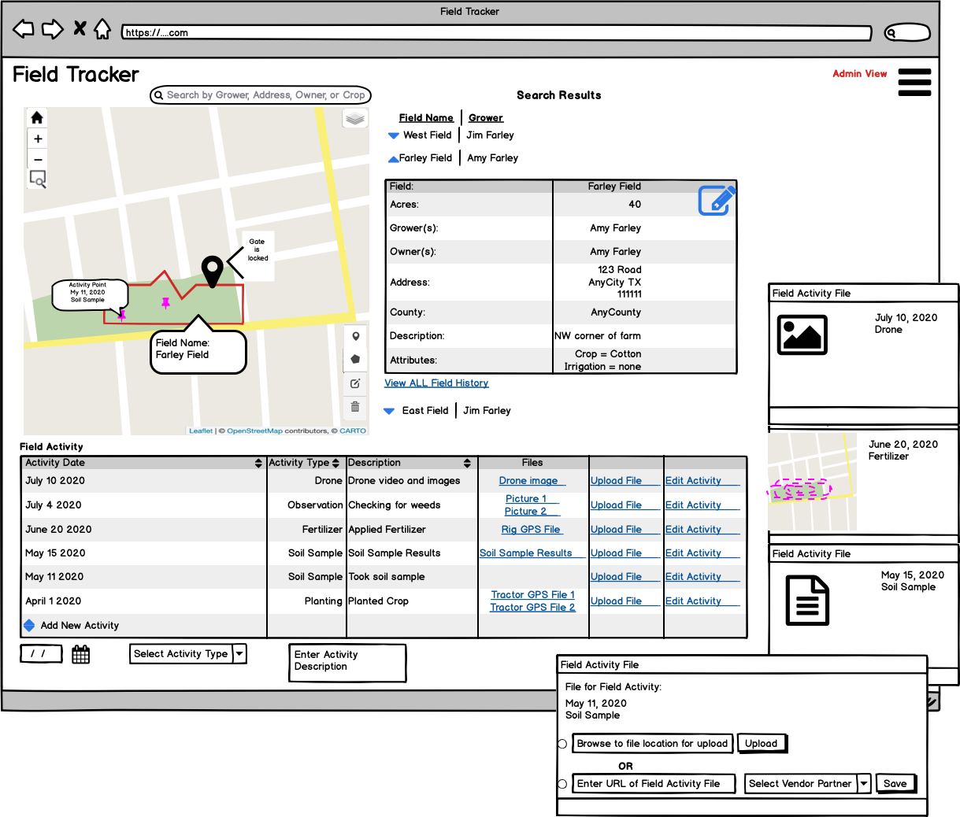

**Figure 2.** Mockup of main page showing map and field data with popup window examples

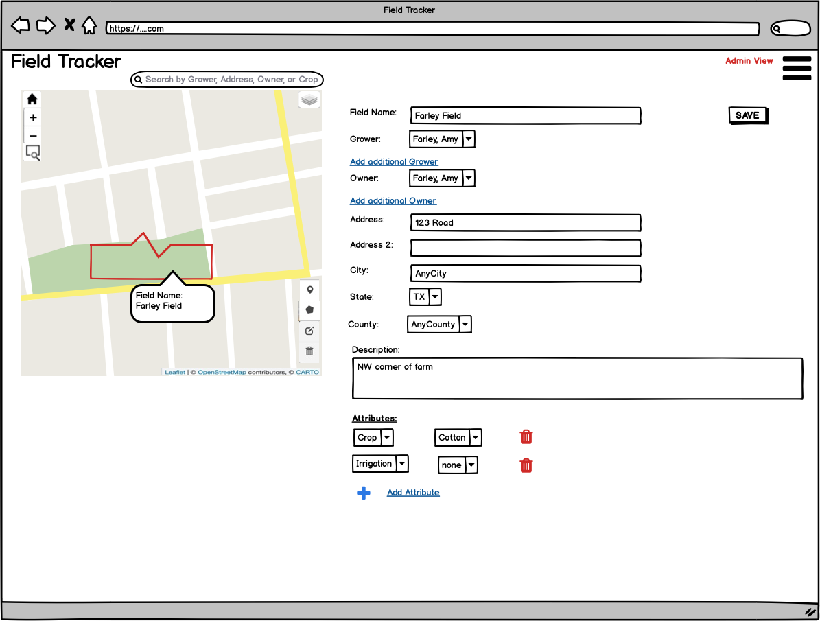

**Figure 3.** Mockup of field properties edit screen

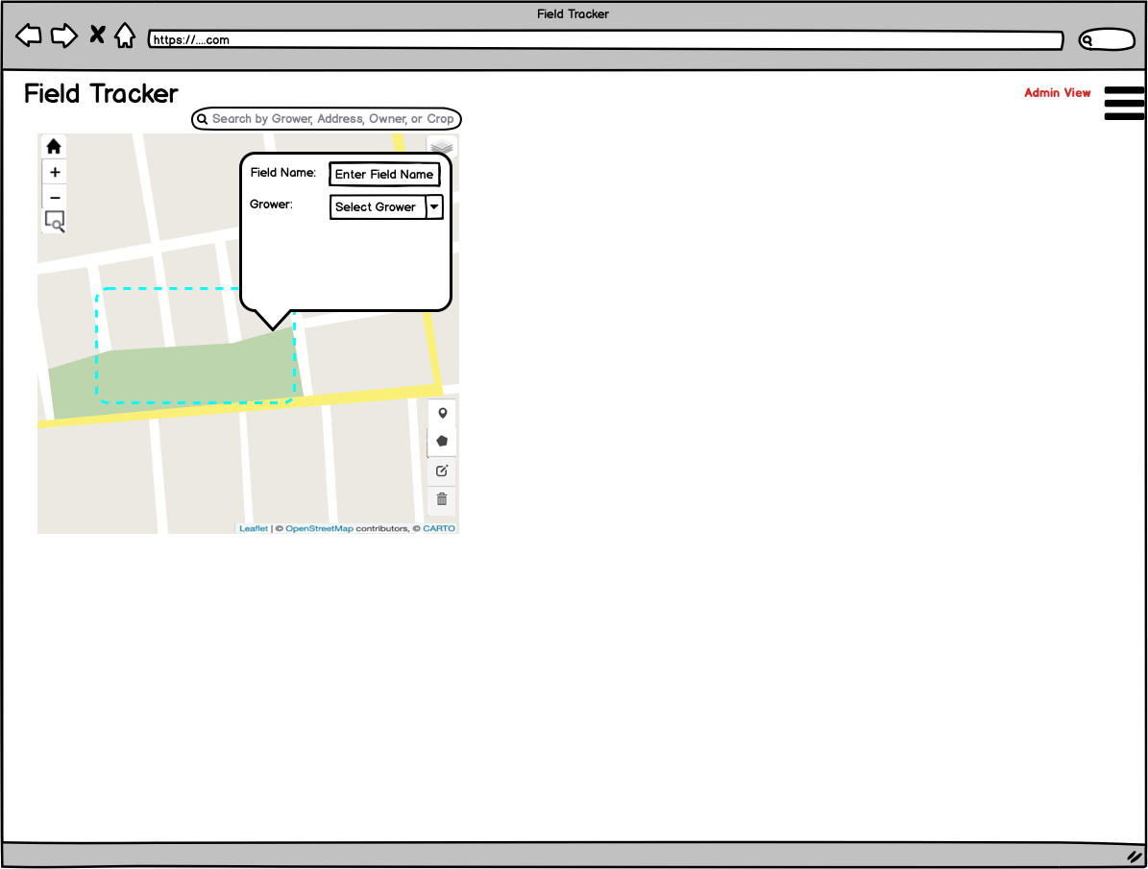

**Figure 4.** Mockup of field addition functionality

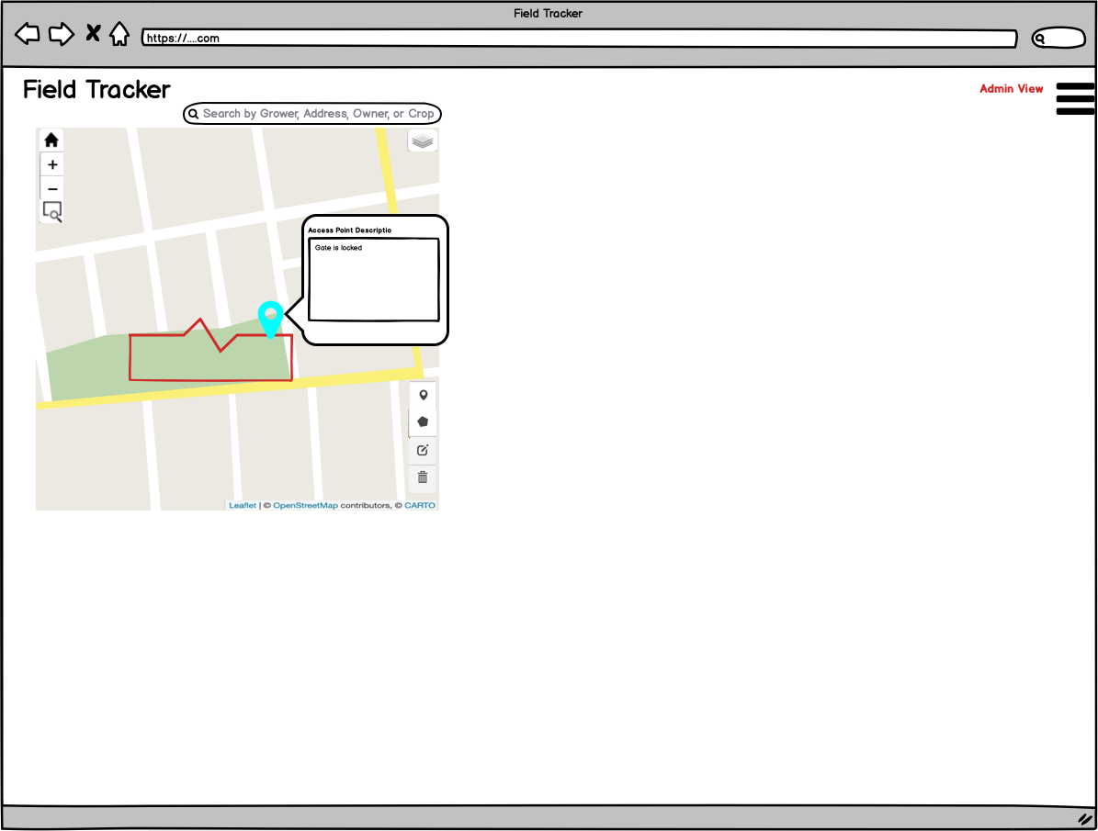

**Figure 5.** Mockup of future field access point addition functionality

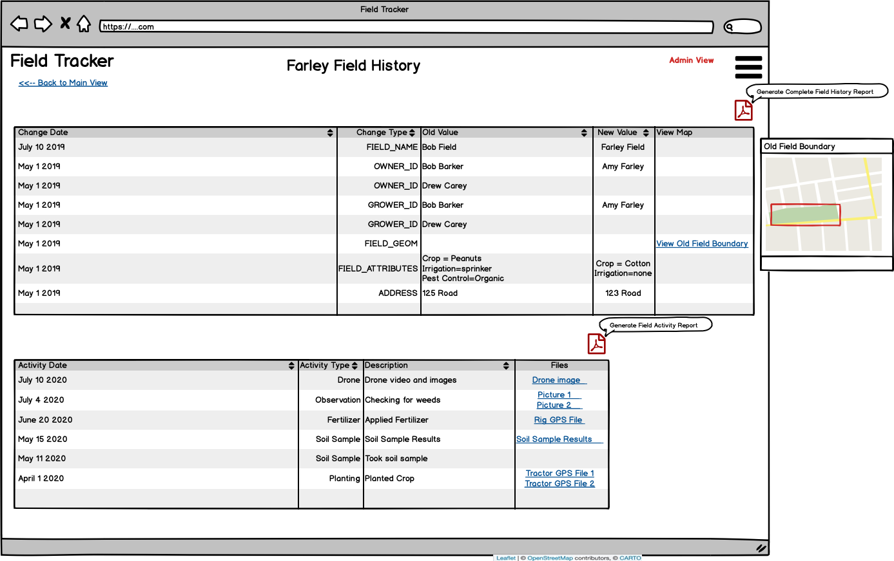

**Figure 6.** Mockup of field history display with popup window example

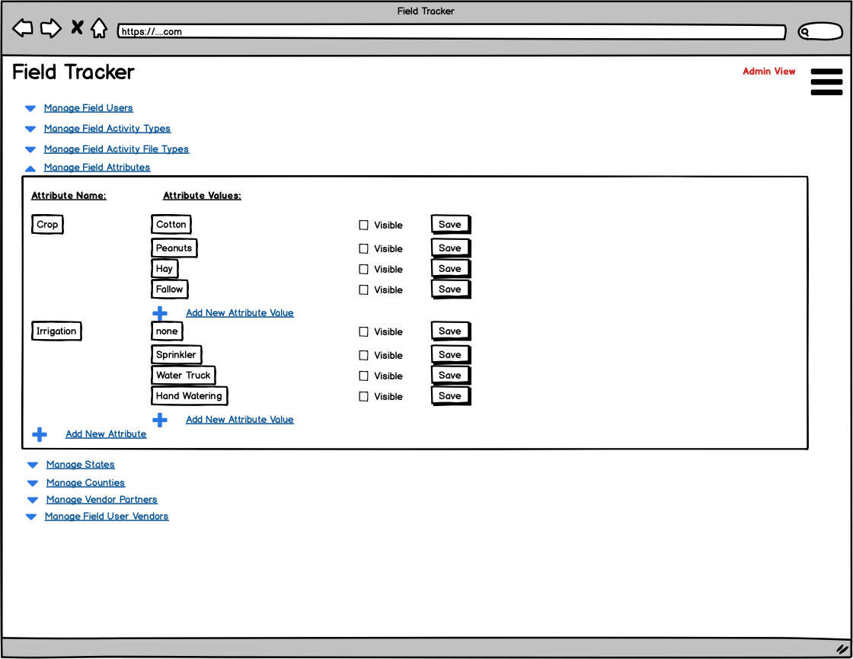

**Figure 7.** Mockup of lookup table administration screen for administrative users

These mockups are not exhaustive. Editing the vector data displayed on the map will be allowed. The open-source mapping framework Leaflet has many plug-in libraries for drawing shapes on the map. Within one of these libraries is the functionality for modifying existing features. Adding a point location for field activity is a feature that will be included in future versions of the application. It will most-likely be handled when editing an activity record. The actual interface specifics for that are yet to be determined. Finally, future versions may also allow georeferenced imagery to become layers or basemaps in the map itself. Again, the technical steps needed to make that happen require further investigation.

# Database Design

While many database models exist, the project will employ the most-widely used relational database model. This will ensure efficient data storage and ease of data manipulation in the web-mapping application using the standard Structure Query Language (SQL). Redundancy of data will be minimized. Data will be normalized for ease of querying. Additionally, the relational database design itself is independent of the database management system or underlying platform and can be re-used in different technology solutions.

Because the MGIS capstone project focuses on open-source solutions, the RDBMS is PostgreSQL with PostGIS extensions. The  Amazon Relational Database Service (Amazon RDS) services include a PostgreSQL option with the ability to load the PostGIS extensions. (Amazon Web Services, 2020) While the Amazon RDS is not technically “serverless” because it is always up and running regardless of use, it can be migrated to a “serverless” version using the Amazon Aurora with PostgreSQL compatibility service. Amazon representative Joe Flasher explained the distinction between constantly-available Amazon RDS and the available-on-demand Amazon Aurora options. He pointed out that if the application is not used often, then Amazon Aurora makes sense. Otherwise, Amazon RDS is a better option as the cost difference would not be significant and performance would be better. (Flasher, 2020) For the MGIS capstone project, the constantly-available Amazon RDS for PostgreSQL will be used. PostGIS extensions will be loaded to manage the geospatial data.

Because the database design must accommodate the needs of the UI, at least one other module will be used to encrypt sensitive password data. The **pgcrypto** module is recognized as a way to encrypt certain columns in PostgreSQL. (The PostgreSQL Global Development Group, 2020)

The overall design takes into account the data specifications along with initial and future UI considerations. Data integrity is maintained with the usage of lookup tables and table relationships with foreign key constraints. Every table has a primary key field to ensure uniqueness for every record in the table. Special attention to data type selection and sizing was given based on anticipated record quantities. Because cost containment is a key concern in the overall project, space allocations should be just large enough to handle all future growth. Over-allocating space equals paying for space that will never be used.

One of the main aspects the database design accommodates is the idea of forever-changing field attributes (and attribute values). This is further discussed below as I have professional experience with these situations. PostgreSQL has a data type that provides a very clever solution to a long-standing challenge in database design.

## Entity-Relationship (ER) Diagram

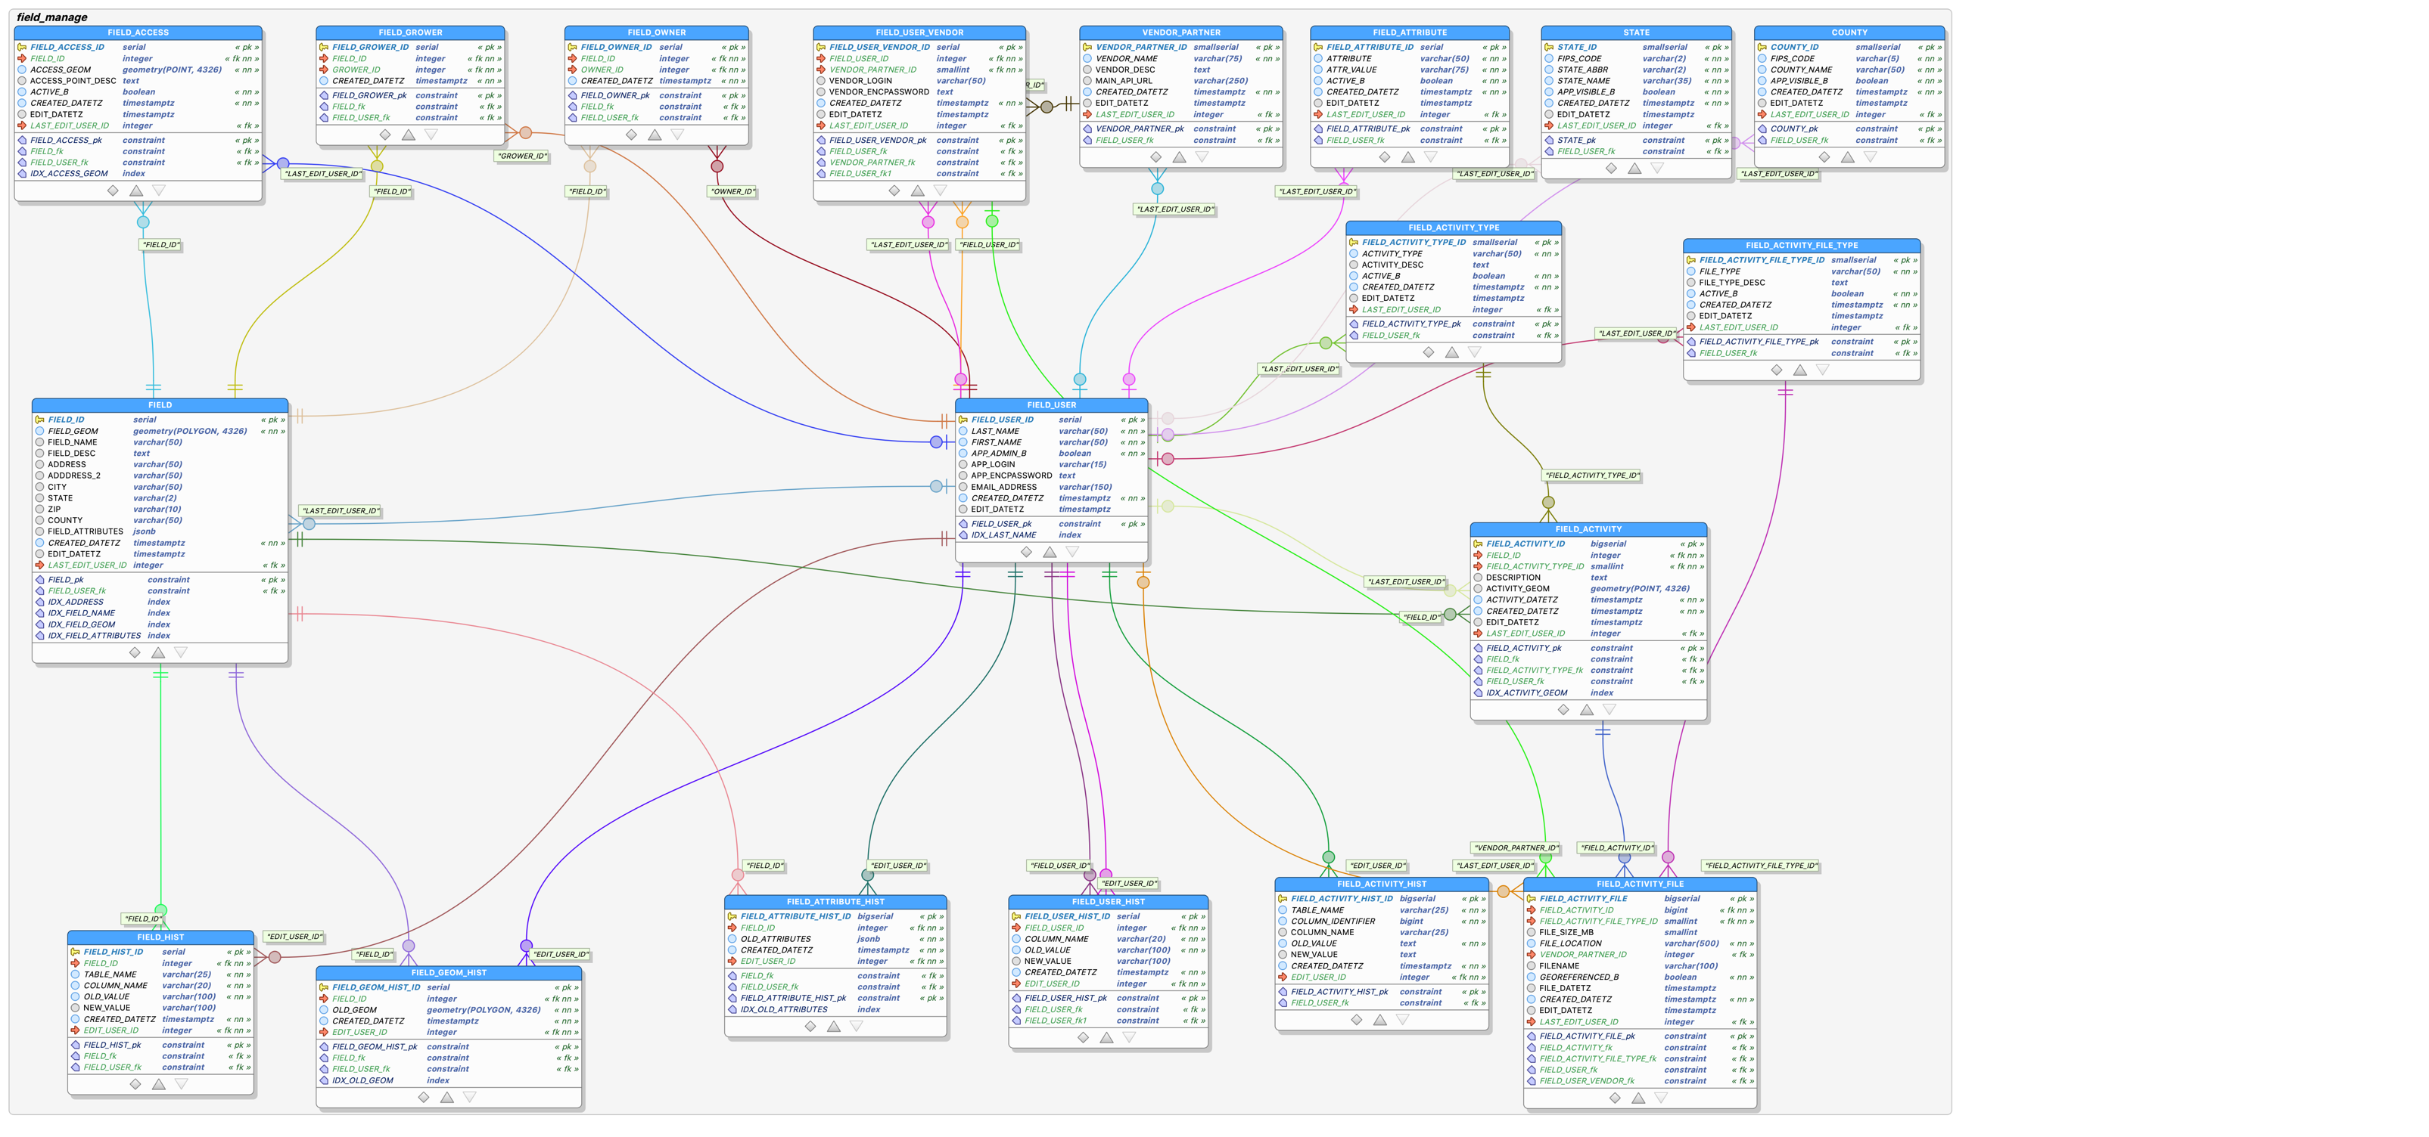**Figure 8.** ER Diagram for MGIS Capstone Project

## Explanation

The ER diagram was produced using the pgModeler for PostgreSQL. The data types chosen are specific to PostgreSQL and PostGIS. I also used pgModeler to generate the data description language (DDL) statements in a large SQL file that could be run to create all the database objects. The ER diagram above displays all table names and field names in uppercase for readability. Before running the DDL statements to create all the database objects, I did have to modify the SQL script. pgModeler puts double quotes around the table and field names in uppercase. These have to be removed or they will get created in the database as uppercase and all SQL queries will need to double quote the table and field names. (Lefebvre, 2016) (Araújo e Silva, 2017) (anthonydb, 2017) Everything in the entire SQL script was converted to lowercase. The geometry field additions were changed to use the PostGIS **AddGeometryColumn** function. Once the schema and objects were created in the database hosted on AWS, I was able to re-import the entire database with pgModeler. This creates a new ER diagram that looks a bit different. Figure 9 shows the ER diagram that is automatically generated by importing from an existing PostgreSQL database. The serial data types are now integer data types. Other data types are labeled differently as well. The painstaking work cleaning up the relationship lines and labels is lost.

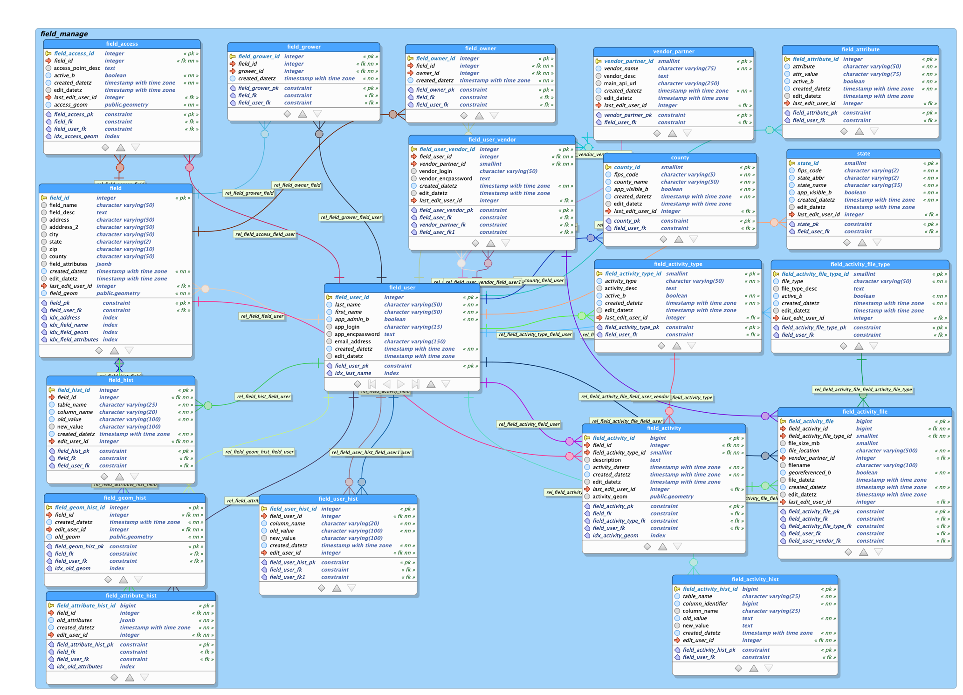

**Figure 9.** ER Diagram from PostgreSQL import

### Main Entity Tables and Junction Tables

As previously stated, data is organized around the agricultural fields. The key entity tables are:

* FIELD
* FIELD_USER
* FIELD_ACTIVITY
* FIELD_ACTIVITY_FILE

Junction tables for the many-to-many relationships that can exist between fields and growers and between fields and landowners are:

* FIELD_GROWER
* FIELD_OWNER

Looking at the ER Diagram, the FIELD_USER table appears in the middle with relationships to every other table in the database schema. The reason for this is because this table is designed to be multi-purpose. Field Users are not just the growers or landowners. Field Users are also the web-mapping application users that will be managing the field data. Field Users are even web-mapping application users that manage just the application data. To avoid data replication, this table serves as almost an anchor to everything in the overall application. It is entirely possible that a single user can be a grower, a landowner, and an application user. There is no reason to store that user in three different places. Simply having one table with foreign key constraints to the other tables eliminates redundancy in the data.

FIELD_GROWER and FIELD_OWNER tables imply that these are properties inherent in field data and should be essential to identifying a field. They are simple tables with relationships back to the FIELD_USER table.

FIELD_ACTIVITY and FIELD_ACTIVITY_FILE store the records associated with any activity performed on the FIELD record. I’ve added a Point geometry column to this table in case a user has very specific coordinates for a particular observation activity. I do not anticipate that this field will be populated very often.

Looking closer at the FIELD table itself, one will notice that it is a simple table with only a few columns. This is where the discussion around dynamic attribution comes into play. In my own experience and in conversations with friends in the technology industry, deciding how to handle for unknown and/or ever-changing entity properties is a source of debate and differing opinions. A blog post from a Belgium technologist sums it nicely. “It must be one of the oldest use cases in the world of relational databases: you have an entity, and you need to store certain properties of this entity. But, not all entities have the same set of properties, and properties will be added in the future.” He goes on to explain that the most “naïve” way to handle this is to constantly add columns to your entity table. (Coussement, 2016) This is simply not sustainable. A table could end up with hundreds of columns and millions of records that have null values in most of the columns. Adding columns also means frequent database schema changes which can negatively impact applications with heavy traffic accessing the database.

Coussement continues by delving into the Entity-Attribute-Value (EAV) pattern. This is the pattern (or at least a derivation of it) that I have seen most often in my professional career. In this pattern, there is the entity table, a table to hold the attribute names, and a junction table that stores the entity id, attribute id, and attribute value. (Coussement, 2016) In my professional experience, the pattern followed is only two tables. The second table holds both the attribute and attribute value along with the entity id. In this situation, the uniqueness of the attribute is maintained through the application code not the use of a primary key in the database. Either way, what ends up happening is the junction table containing the entity attribute values grows exponentially and records for a single entity can span across millions of records. Of course, indexing on the table can speed up queries, but a query to find all entity attributes and values means joining two to three tables to get the full picture. Conversations with friends in the industry reveal that this has been the long-accepted approach to managing this type of data though. I do not know anyone that loves it. It has simply been the accepted approach.

Enter the PostgreSQL JSON data type. I had stumbled upon this before and wondered about it. Essentially, this data type allows for storage of key-value pairs In the JavaScript Object Notation (JSON) data-interchange format in a single column. In other words, all the attributes for an entity can be stored in a single column on the same record as the entity itself. PostgreSQL actually has two JSON data types. In most cases, the JSONB data type is recommended. (The PostgreSQL Global Development Group, 2020) (PostgreSQL Tutorial, 2020) It is this data type that Coussement investigates and uses to create performance comparisons between attributes stored in this format versus attributes stored in the EAV pattern. His results showed that the performance difference when querying and updating is negligible compared to EAV with indexing. The biggest win for JSONB over EAV is the amount of space saved. His tests showed that the JSONB data type resulted in a database 3 times smaller. While this data type does require very specific query syntax, it is still simple and does not require table joins nor multiple record returns. (Coussement, 2016) Examples of how to query tables with JSONB columns are illustrated later in this document.

The FIELD.FIELD_ATTRIBUTES column in the database design is of data type JSONB. To ensure data consistency, the application will not allow free-form attribute name nor attribute value additions. All attribute names and possible attribute values will be stored in the FIELD_ATTRIBUTE table. This table may be maintained by an administrative user of the web-mapping application. The FIELD_ATTRIBUTE table contains an ACTIVE_B boolean field that will be used by the web-mapping application to determine whether or not to make an attribute and/or attribute value visible for selection.

### Lookup tables

The FIELD_ATTRIBUTE table discussed above is one of several lookup tables included in the database design to ensure data consistency and accuracy. These tables are included primarily for use by the web-mapping application. These tables will serve as the source for many of the form drop-down options.

Most of the lookup tables are obvious when comparing the ER diagram with the UI mockups. For example, the STATE and COUNTY tables will populate the respective form drop-down options on the Edit Field screen of the UI. The FIELD_ACTIVITY_TYPE table will limit the activity type options when adding a field activity record from the UI. Again, the FIELD_ATTRIBUTE table is intended to limit both the attribute and valid attribute value options available on the Edit Field screen.

In essence, the FIELD_USER table serves as a lookup table when editing fields. Limiting these associations to only valid options from a drop-down list ensures that names are not duplicated.

VENDOR_PARTNER is a lookup table to store the different vendor partners that may have field activity data stored on that vendor’s platform accessible via a URL or Application Programming Interface (API). FIELD_USER_VENDOR may technically be a junction table for the many-to-many relationships between field users and vendor partners, but it is also a lookup table for the FIELD_ACTIVITY_FILE table. Described in the data specifications, activity files could be stored on a vendor’s proprietary storage system.

### History Tables

Preserving the history of a field is an important feature of the overall application. Several history tables are included in the database design along with the CREATED_DATETZ, EDIT_DATETZ, and LAST_EDIT_USER_ID fields in most of the database tables. This not only allows for reviewing field changes over time, but it also provides an auditing mechanism by keeping track of who is changing what.

Not depicted in the database design are the possible database triggers tied to specific tables to INSERT records into the *_HIST tables and UPDATE the EDIT_DATETZ and LAST_EDIT_USER_ID fields of the tables undergoing record UPDATES. Changes to the junction tables FIELD_GROWER and FIELD_OWNER will be INSERT or DELETE. The DELETES will be recorded in a history table. Because these two tables are simple junction tables where associations between field user and field are either added or deleted, the edit fields present in other tables are absent in these two.

The database triggers would NOT be triggered upon INSERTS. This is a common approach I have seen in my professional career. Once I have the database created on AWS, I plan to pursue the creation of these triggers. The tables that will be subject to trigger addition are:

* FIELD
  + Changes to the field boundary (GEOM column) will be recorded in the FIELD_GEOM_HIST table
  + Changes to the attributes (FIELD_ATTRIBUTES column) will be recorded in the FIELD_ATTRIBUTE_HIST table
  + Changes to name, description, and address fields will be recorded in the FIELD_HIST table
* FIELD_GROWER and FIELD_OWNER
  + Record deletions in these tables will be stored in the FIELD_HIST table
* FIELD_USER
  + Changes in this table will be stored in the FIELD_USER_HIST table
* FIELD_ACTIVITY and FIELD_ACTIVITY_FILE
  + Changes to non-spatial columns in these tables will be stored in the FIELD_ACTIVITY_HIST table

Tables that will not be subject to historical record, but still require most recent edit information to be recorded are:

* FIELD_ACCESS
* Lookup Tables
  + FIELD_ACTIVITY_TYPE
  + FIELD_ACTIVITY_FILE_TYPE
  + FIELD_ATTRIBUTES
  + STATE
  + COUNTY
  + VENDOR_PARTNER
  + FILE_USER_VENDOR

The justification for subjecting some tables to historical record preservation centers around what data might be required for transparency in terms of food/product production. Field access points (the locations of the gates) or the lookup table values are not something that needs to be shared with consumers in the context of food production transparency.

The FIELD_HIST table is designed to store records from FIELD, FIELD_GROWER, and FIELD_OWNER. It contains columns for the TABLE_NAME, FIELD_ID, OLD_VALUE, and NEW_VALUE. As stated before, the *_HIST tables contain records that are the result of UPDATES and DELETES in the main entity tables. Because of this, OLD_VALUE is required but NEW_VALUE is not. There will always be a value for OLD_VALUE since INSERTS are not recorded here. Allowing for null values in the NEW_VALUE field accommodates DELETES.

FIELD_USER_HIST is designed just the FIELD_HIST table. This table only stores the history of the FIELD_USER table so the TABLE_NAME field is not necessary here. Again, it only contains records tied to FIELD_USER UPDATES and DELETES.

FIELD_ACTIVITY_HIST is like the FIELD_HIST table for FIELD_ACTIVITY and FIELD_ACTIVITY_FILE tables. Unlike FIELD_HIST where every record pointed back to a single FIELD_ID, this table has a field called COLUMN_IDENTIFIER to store the primary key value for FIELD_ACTIVITY or FIELD_ACTIVITY_FILE. I anticipate this particular history table serving as more of an audit table than preserving historical record. Once an activity and/or activity file is entered, reasons for updates or deletions will be due to data entry mistakes. An activity represents a moment in time, so it is a historical record by nature.

FIELD_GEOM_HIST and FIELD_ATTRIBUTE_HIST are separated from FIELD_HIST to store changes to the “special” data type columns in the FIELD table. Numbers and dates can be easily converted to text but converting the Geometry and JSON data types to text will adversely impact the web-mapping application. Historical geometries must be viewable in a map. Historical field attributes must be able to be queried the same way current field attributes are queried with the JSON-specific query syntax.

## Indexing

The UI mockups indicate that users should be able to search by certain field properties such as field name or grower name. In order to improve query performance, indexes have been added to the fields that may be used for field searching. Spatial indexes have been added to the geometry fields for performance with spatial querying.

### Attribute Indexing

According to the PostgreSQL documentation, the most common index type is B-tree. (The PostgreSQL Global Development Group, 2020) B-tree indexes have been added to the following fields:

* FIELD_USER.LAST_NAME
* FIELD.ADDRESS
* FIELD.FIELD_NAME

### Spatial Indexing

Generalized Search Tree (GiST) indexing is used for PostgreSQL two-dimensional geometric data by default. (Detwiler & Sloan, 2020) (The PostgreSQL Global Development Group, 2020) (Ramsey & Leslie, Spatial Indexing, 2012) I anticipate querying geometries by bounding boxes or by historical geometries using some of the PostGIS spatial relationship functions. In order to get the best possible query performance, a spatial index has been added to the two geometry columns specified in the database schema. Those fields are:

* FIELD.FIELD_GEOM
* FIELD_ACCESS.ACCESS_GEOM
* FIELD_GEOM_HIST.OLD_GEOM
* FIELD_ACTIVITY.ACTIVITY_GEOM

### JSONB Indexing

PostgreSQL documentation states, “GIN indexes can be used to efficiently search for keys or key/value pairs occurring within a large number of jsonb documents (datums).” (The PostgreSQL Global Development Group, 2020) In order to make queries in JSONB columns more efficient, GIN indexes have been added to the following:

* FIELD.FIELD_ATTRIBUTES
* FIELD_ATTRIBUTE_HIST.OLD_ATTRIBUTES

# Required Queries

The UI mockups provide insight into the types of queries that will be necessary to display the data in the web-mapping interface. As stated before, the “serverless” nature of the overall application architecture means that the geospatial data must be transferred to/from database and UI in specific format. Traditionally, geospatial data is served to a web-mapping interface by way of a geospatial application layer. Often, this application transforms the geospatial data into images or other data formats that are passed to the UI. In the serverless architecture, there will be no transformation to map image files. The geographic data is passed directly to the UI and then transformed in the user’s browser for map display. The modern, open-source mapping framework Leaflet accepts GeoJSON data as a mapping layer. Since this is the framework that will be used to construct the map display of the UI, the geospatial data passed from the database needs to be in this format. Fortunately, PostGIS has functions that allow for this.

As noted earlier, the JSONB data type in the FIELD table will require specific query syntax for retrieving and storing the field attributes data.

Finally, specified in the Project Criteria section of this document is the fact that the geospatial data will be stored in a geographic coordinate system, but the web-mapping display must be in a projected coordinate system. The default projection used by the Leaflet framework is EPSG:3857. (Agafonkin & OpenStreetMap contributors, 2019) This means that the geospatial data will need to be transformed when being passed between UI and database.

The JSON query syntax and JSON data type functions belong to the PostgreSQL database system. PostGIS functions are used for managing the spatial data. (The PostgreSQL Global Development Group, 2020) (PostGIS Project Steering Committee (PSC), n.d.)

## Sample Data INSERT Statements

* insert into field_user (last_name, first_name, app_admin_b, created_datetz) values ('Farley', 'Jim', true, **current_timestamp**);

## Sample Geometry INSERT Statements

For initial testing, I added a few records using the Well-Known Text (WKT) loading functions. I knew the source was already in EPSG:4326, but I wanted to establish INSERT patterns that made sure the source data coordinate system is defined along with the geometry column coordinate system when loading the geometry data.

* INSERT INTO field(field_name, field_geom, created_datetz)   
  VALUES ('Dad''s Cultivated',   
  **ST_Transform**(**ST_GeomFromText**('POLYGON ((-98.65070837415604 32.11573800144451,   
  -98.65068476156632 32.11272911539712,   
  -98.64202112847605 32.11256941997059,  
  -98.64220500984801 32.11965087237952,   
  -98.65042344396167 32.1195293065847,  
  -98.65035994776281 32.11814307220845,  
  -98.64557713898905 32.11811726268408,  
  -98.64545238256078 32.11382619598167,  
  -98.647344869717 32.11378472039517,  
  -98.6475887771383 32.11564451081091,   
  -98.65070837415604 32.11573800144451))',4326),4326), **current_timestamp**)   
  **RETURNING field_id**;
* INSERT INTO field(field_name, field_geom, created_datetz)   
  VALUES ('Mom''s Tifton',   
  **ST_Transform** (**ST_GeomFromText**('POLYGON ((-98.65615282876533 32.11240724346765,  
  -98.65614029405009 32.10938020882313,  
  -98.65083573198936 32.10937395329969,  
  -98.65082758527537 32.11245023125252,  
  -98.65615282876533 32.11240724346765))',4326),4326), **current_timestamp**)   
  **RETURNING field_id**;

Originally, I was looking at the ST_GeomFromKML and ST_GeomFromGeoJSON because I already have some KML files produced from Google Earth. After reviewing the documentation, I realized that I would have to extract out fragments from these formats. (PostGIS Project Steering Committee (PSC), n.d.) This will come in handy when I write scripts to iterate through multiple KML files (that contain one or more field boundaries), parse them, and insert records from the KML fragments. Because the KML fragments have z-index values that the ST_GeomFromKML will keep because it supports 3-dimensional geometries, I had to wrap this function in the ST_Force2D for the INSERT into the 2-dimensional FIELD_GEOM column to work. The same applied to the ST_GeomFromGeoJSON function. (PostGIS Project Steering Committee (PSC), n.d.)

* INSERT INTO field(field_name, field_geom, created_datetz) VALUES ('Spruill Pivot', **ST_Transform**(**ST_Force2D**(**ST_GeomFromKML(**'<Polygon><tessellate>1</tessellate>  
  <outerBoundaryIs><LinearRing>  
  <coordinates>-98.61937891559366,32.11745075313696,0 -98.62048693823859,32.11437816465637,0 -98.61432749628111,32.11271745766126,0 -98.61317965949985,32.11567421223258,0 -98.61685594392591,32.11669632782378,0 -98.61907073078436,32.11762595989298,0 -98.61937891559366,32.11745075313696,0 </coordinates>  
  </LinearRing></outerBoundaryIs></Polygon>')),4326), **current_timestamp**) **RETURNING field_id**;
* INSERT INTO field(field_name, field_geom, created_datetz) VALUES ('Underwood', **ST_Transform**(**ST_Force2D**(**ST_GeomFromGeoJSON**('{ "type": "Polygon", "coordinates": [ [ [ -98.753613128578579, 32.159439629851128, 0.0 ], [ -98.753645688705845, 32.158532385898653, 0.0 ], [ -98.753668129741726, 32.157815848923001, 0.0 ], [ -98.753754122779398, 32.156657960157183, 0.0 ], [ -98.753747807369024, 32.155989927040068, 0.0 ], [ -98.753717397281406, 32.154209677788188, 0.0 ], [ -98.753656382136256, 32.153172101503053, 0.0 ], [ -98.753642625993194, 32.152721654373273, 0.0 ], [ -98.752508318791044, 32.152679883297203, 0.0 ], [ -98.751751584507488, 32.152849607902333, 0.0 ], [ -98.751431167737209, 32.152491993781531, 0.0 ], [ -98.751290840246995, 32.152001796849497, 0.0 ], [ -98.751341895875584, 32.150939242803311, 0.0 ], [ -98.751418532605385, 32.150180353063753, 0.0 ], [ -98.751403085948141, 32.149496163529292, 0.0 ], [ -98.751408322468009, 32.148894214229237, 0.0 ], [ -98.750007394426873, 32.148894851261439, 0.0 ], [ -98.748835838770319, 32.148863649547422, 0.0 ], [ -98.747904758638896, 32.148911694807879, 0.0 ], [ -98.747054098728313, 32.148848615427838, 0.0 ], [ -98.746954659813582, 32.149365531779218, 0.0 ], [ -98.746947670736162, 32.150007805323597, 0.0 ], [ -98.746131264769701, 32.150574645829657, 0.0 ], [ -98.745384048310726, 32.151109969989129, 0.0 ], [ -98.745354015317304, 32.15230843003399, 0.0 ], [ -98.745401787173449, 32.155003064800127, 0.0 ], [ -98.745390242217539, 32.156742244456197, 0.0 ], [ -98.745440587071542, 32.15787642007119, 0.0 ], [ -98.746603395438953, 32.157905474002099, 0.0 ], [ -98.746562884565847, 32.159249504547311, 0.0 ], [ -98.749108164177244, 32.159408427931957, 0.0 ], [ -98.75097419434185, 32.159440120962863, 0.0 ], [ -98.752766637091696, 32.159439781933649, 0.0 ], [ -98.753613128578579, 32.159439629851128, 0.0 ] ] ] } ')),4326), **current_timestamp**) **RETURNING field_id**;

To confirm I was loading everything into the database correctly, I used QGIS to compare the original KML layer with the layer from the PostGIS database. Figure 10 is the map layout of the field boundaries comparing the original KML as a layer (in pink outlines) with the PostGIS record inserts (in brown fill) as another layer.

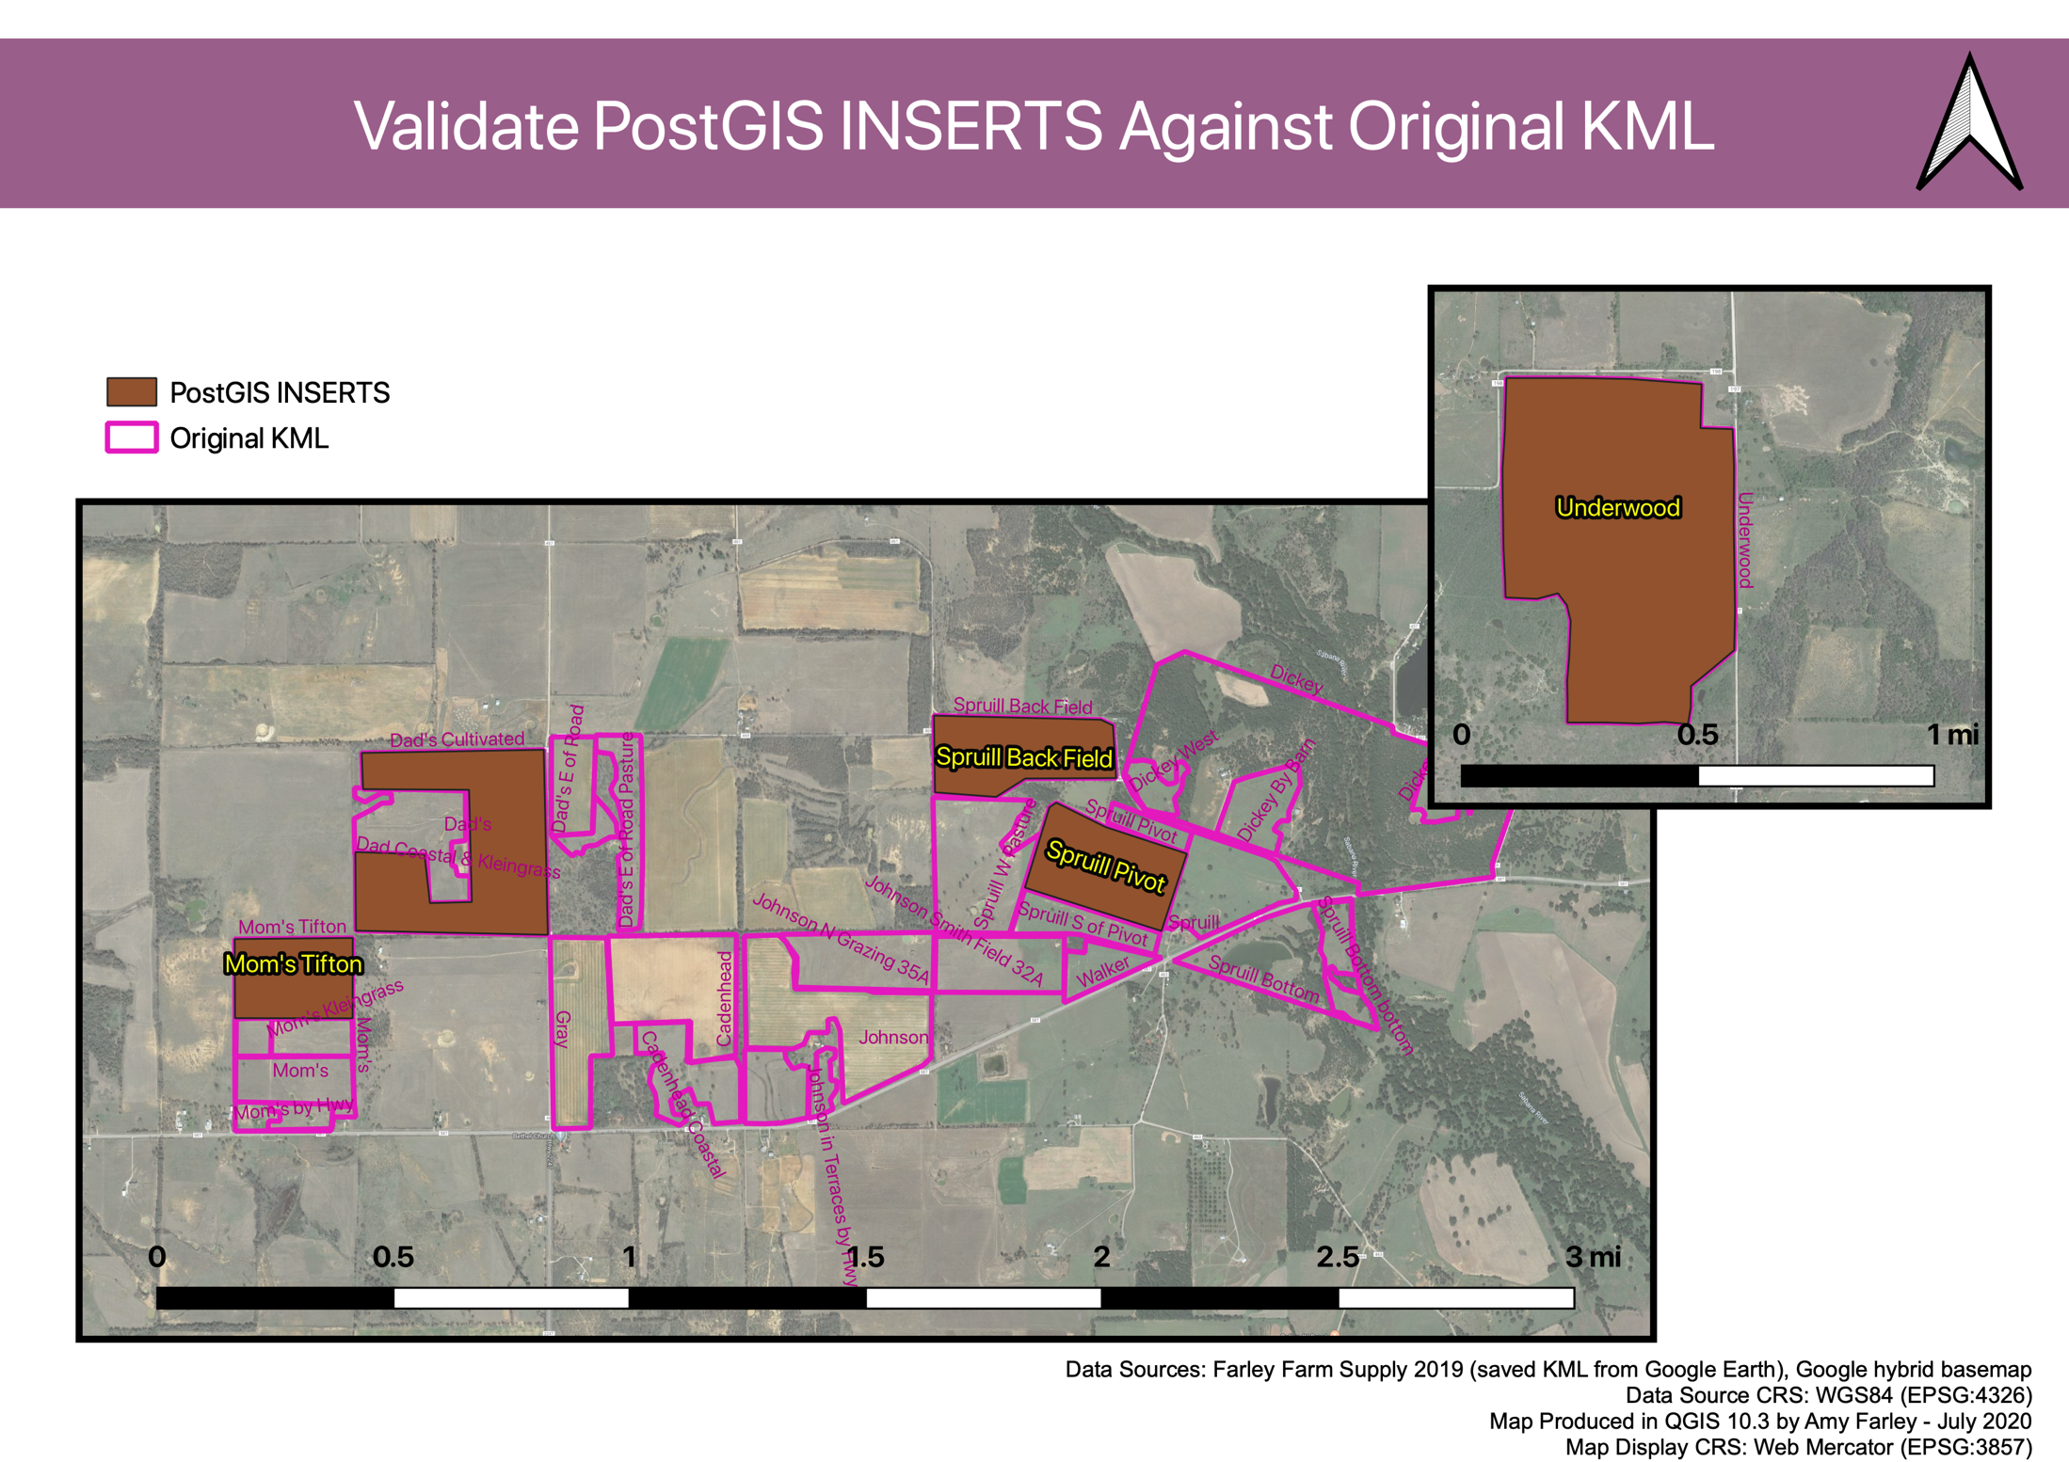

**Figure 10.** Map Layout depicting PostGIS INSERT validation against original KML

## Sample Geometry SELECT Statements

The mapping interface will be built using the open-source Leaflet framework. Leaflet can add layers from several different sources. Web map service (WMS) layers can be added as image tile layers. Vector layers can be added by specifying individual features or by using GeoJSON. (Agafonkin & OpenStreetMap contributors, 2019) In the MGIS capstone project, the serverless AWS Lambda functions will be responsible for querying the PostgreSQL/PostGIS database and transforming the records into a format recognized by Leaflet. PostGIS has a function for returning data in GeoJSON format. Because the web mapping display will be using EPSG:3857 as the coordinate system, the data will also require on-the-fly reprojection. (PostGIS Project Steering Committee (PSC), n.d.)

* select field.field_name,   
  **ST_AsGeoJSON**(**ST_Transform**(field.field_geom, 3857)) as field_boundary,   
  field_user.first_name|| ' ' ||field_user.last_name as grower  
  from field   
  left outer join field_grower   
  on field.field_id = field_grower.field_id   
  inner join field_user  
  on field_grower.grower_id = field_user.field_user_id;

Table 1 shows a comparison of the records returned when transforming versus not transforming to a different coordinate system. The records that have been re-projected on-the-fly with the ST_Transform function carry an additional key specifying the coordinate reference system. Those records contain "crs":{"type":"name","properties":{"name":"EPSG:3857"}}.

**Table 1. Compare GeoJSON returned upon SQL Query**



**\*SQL Query:** select field.field_name, ST_AsGeoJSON(ST_Transform(field.field_geom, 3857)) as field_boundary, field_user.first_name|| ' ' ||field_user.last_name as grower from field left outer join field_grower on field.field_id = field_grower.field_id inner join field_user on field_grower.grower_id = field_user.field_user_id

*union*

select field.field_name, ST_AsGeoJSON(field.field_geom) as field_boundary, field_user.first_name|| ' ' ||field_user.last_name as grower from field left outer join field_grower on field.field_id = field_grower.field_id inner join field_user on field_grower.grower_id = field_user.field_user_id order by field_name;

It may be necessary to return the area of a field in the acre unit of measure. According to the PostGIS documentation, the ST_Area function computes the area of geometry data types with the units specified by the SRID. (PostGIS Project Steering Committee (PSC), n.d.) Because EPSG:4326 is in degrees, I projected to a coordinate system specific to the area of Texas where the field boundaries lie. Universal Transverse Mercator (UTM) Zone 14N (EPSG:26914) is a better option for this particular area because this area encompasses two State Plane zones.

* select (**st_area**(**st_transform**(field_geom,26914)) * 0.00024710538146717) as area_acres from field where field_id = 6;

## Sample JSON SQL

The official PostgreSQL documentation has decent reference information for the JSON data type and all of the JSON functions and operators. I did find a tutorial with more straightforward information on INSERT and SELECT queries. The tutorial broke down exactly which operators to use to query the JSON data itself. There are specific operators for querying the JSON nodes. (The PostgreSQL Global Development Group, 2020) (PostgreSQL Tutorial, 2020)

* UPDATE field SET field_attributes = '{ "crop": "cotton", "irrigation": "none"}' WHERE field_id=2;
* SELECT field_name,   
  field_attributes ->> 'irrigation' as irrigation_system,   
  field_attributes ->> 'crop' as crop  
  FROM field   
  WHERE  
  field_attributes ->> 'crop' = 'cotton';
* UPDATE field   
  SET field_attributes = **jsonb_set(**field_attributes,'{"crop"}', '"wheat"')   
  WHERE field_id = 3;

The real power of this data type is when combined with PostGIS spatial relationship functions. It is entirely possible that the UI may eventually allow queries for all fields of a specific crop that fall within a bounding box.

* SELECT field_name, field_attributes ->> 'irrigation' as irrigation_system, field_attributes ->> 'crop' as crop, **ST_Contains**(**ST_Transform**(**ST_MakeEnvelope**(-98.7540438321756397,32.1050599181344865,-98.5599342262939757,32.2062253936398903,4326), 4326),field_geom) FROM field WHERE field_attributes ->> 'crop' = 'cotton';

## Encrypted Fields

Once the **pgcrypto** extension has been created on the database, inserting and retrieving encrypted values in fields is done with encryption functions. (Avrem, 2019) (The PostgreSQL Global Development Group, 2020)

Examples of this are:

* set search_path to public,field_manage; - *\*This is very important because the extension is loaded to the public schema*
* update field_user set app_login = 'farleyjim', app_encpassword = **pgp_sym_encrypt**('password', 'aes') where field_user_id = 1;
* select **pgp_sym_decrypt**(app_encpassword::bytea, 'aes') from field_user where **pgp_sym_decrypt**(app_encpassword::bytea, 'aes') ='password';

## Future Considerations

The UI could ultimately allow for distance measuring between fields or between fields and roadways. ST_Distance could be used to measure distances between all fields creating a Cartesian product of fields joined to itself with a cross join.

* SELECT fieldA.field_name, fieldB.field_name,   
  **ST_Distance**(**ST_Transform**(fieldA.field_geom,26914), **ST_Transform**(fieldB.field_geom,26914)) * 0.000621371 as distance_miles  
  FROM field as fieldA **CROSS JOIN** field as fieldB  
  WHERE fieldA.field_name != fieldB.field_name;

It could be necessary to know which fields lie within a certain distance of one another. Below is an example of fields within two miles of each other.

* SELECT fieldA.field_name, fieldB.field_name, **ST_Distance**(**ST_Transform**(fieldA.field_geom,26914),**ST_Transform**(fieldB.field_geom,26914)) * 0.000621371 as distance_miles FROM field as fieldA **CROSS JOIN** field as fieldB WHERE fieldA.field_name != fieldB.field_name and **ST_DWithin**(**ST_Transform**(fieldA.field_geom,26914), **ST_Transform**(fieldB.field_geom,26914),1609.34*2::double precision);

It might also be necessary to know the perimeter of a field boundary.

* select field_name, **ST_Perimeter**(**ST_Transform**(field_geom,26914)) * 0.000621371 as perimeter_miles  
  FROM field;

# Conclusion

This database design is the foundation. Technology along with its applications and data storage systems is ever-evolving. This database is a living organism and will change over time as databases do. Needs change and one cannot anticipate every detail in the beginning. As the overall application is built and tested, requirements will become more granular. New application requirements may impact the overall database design.

This design proposed in this project is a solid start that captures the basic entities and establishes a pattern for preserving historical record as values change. I do not anticipate major changes to these base tables defined in this design. There might be a column addition here and there. A new index may be added. The encryption mechanism for storing sensitive data may change. Database triggers will need to be defined. I might even add another history table for storing activity point changes if the use of them becomes frequent. Overall though, I expect these tables to be stable. The effort taken to identify the correct queries and PostGIS functions truly jump starts the MGIS capstone project. This is research and work required to display and update data in the web-mapping application.

Some of the challenges I expect revolve around loading existing data. For practice, I copied and pasted fragments from existing KML and GeoJSON files. This will not be a long-term solution. I expect I will need to write Python scripts taking advantage of open-source GDAL library ogr2ogr functions to load to the PostgreSQL/PostGIS database.

Finally, in keeping with the spirit of the open-source nature of the MGIS capstone project, the script with all the DDL commands, sample queries, and pgModeler file can all be found at in the public GitHub repository <https://github.com/atxFarley/aws_serverless>.

# References

Agafonkin, V., & OpenStreetMap contributors. (2019). *Leaflet API reference.* Retrieved from Leaflet: https://leafletjs.com/reference-1.6.0.html

Amazon Web Services. (2020). *Migrating Data to Amazon Aurora with PostgreSQL Compatibility*. Retrieved from User Guide for Aurora Feedback : https://docs.aws.amazon.com/AmazonRDS/latest/AuroraUserGuide/AuroraPostgreSQL.Migrating.html

Amazon Web Services. (2020). *PostgreSQL Extensions Supported in the Preview Environment*. Retrieved from PostgreSQL on Amazon RDS: https://docs.aws.amazon.com/AmazonRDS/latest/UserGuide/CHAP_PostgreSQL.html

anthonydb. (2017, March 30). *Why PostgreSQL does not like UPPERCASE table names?* Retrieved from Stack Overflow: https://stackoverflow.com/questions/43111996/why-postgresql-does-not-like-uppercase-table-names

Araújo e Silva, R. (2017, November 10). *After export, I need to quote table name in SQL. #1012*. Retrieved from GitHub - pgmodeler: https://github.com/pgmodeler/pgmodeler/issues/1012

Avrem, A. (2019, Februrary 3). *Encrypt column in PostgreSQL*. Retrieved from https://blog.andreiavram.ro/encrypt-postgresql-column/

Coussement, J. (2016, January 14). *Replacing EAV with JSONB in PostgreSQL*. Retrieved from GitHub: https://coussej.github.io/2016/01/14/Replacing-EAV-with-JSONB-in-PostgreSQL/

Detwiler, J., & Sloan, J. (2020). *GEOG 868 Spatial Database Management*. Retrieved from The John A. Dutton e-Education Institute, College of Earth and Mineral Sciences, Pennsylvania State University: https://www.e-education.psu.edu/spatialdb

Esri. (2020). *Introduction to Spatial References*. Retrieved from Core Concepts: https://developers.arcgis.com/documentation/core-concepts/spatial-references/

Farley, A. (2020). *Academic e-Portfolio - Amy Farley.* Retrieved from Penn State Portfolios: http://personal.psu.edu/alf33/

Farley, J. (2020). Farley Farm Supply. (A. Farley, Interviewer)

Flasher, J. (2020, May 29). AWS Cloud Credits for Research program. (A. Farley, Interviewer)

Frazier, M. (2020). *Overview of Coordinate Reference Systems (CRS) in R*. Retrieved from University of California, Santa Barbara - National Center for Ecological Analysis and Synthesis: https://www.nceas.ucsb.edu/sites/default/files/2020-04/OverviewCoordinateReferenceSystems.pdf

Google. (2020, April 15). *KML Reference.* Retrieved from Google Developers: https://developers.google.com/kml/documentation/kmlreference

Lefebvre, P. (2016, September 28). *About PostgreSQL Case Sensitivity*. Retrieved from https://blog.xojo.com/2016/09/28/about-postgresql-case-sensitivity/

PostGIS Project Steering Committee (PSC). (n.d.). Retrieved 2020, from PostGIS: https://postgis.net

PostgreSQL Tutorial. (2020). *PostgreSQL Cross Join By Example*. Retrieved from PostgreSQL Tutorial: https://www.postgresqltutorial.com/postgresql-cross-join/

PostgreSQL Tutorial. (2020). *PostgreSQL JSON*. Retrieved from PostgreSQL Tutorial: https://www.postgresqltutorial.com/postgresql-json/

Ramsey, P., & Leslie, M. (2012). *Projecting Data*. Retrieved from PostGIS: http://postgis.net/workshops/postgis-intro/projection.html

Ramsey, P., & Leslie, M. (2012). *Spatial Indexing.* Retrieved from PostGIS: https://postgis.net/workshops/postgis-intro/indexing.html

The PostgreSQL Global Development Group. (2020). *Chapter 8. Data Types*. Retrieved from PostgreSQL: The World's Most Advanced Open Source Relational Database: https://www.postgresql.org/

The PostgreSQL Global Development Group. (2020). *Encryption Options*. Retrieved from https://www.postgresql.org/docs/12/encryption-options.html

The PostgreSQL Global Development Group. (2020). *Index Types.* Retrieved from Documentation → PostgreSQL 12: https://www.postgresql.org/docs/current/indexes-types.html

The PostgreSQL Global Development Group. (2020). *JSON Types*. Retrieved from https://www.postgresql.org/docs/12/datatype-json.html

Whitney, B. (2019, October). Ag-related geospatial data. (A. Farley, Interviewer)

Wikipedia contributors. (2020, July 7). *Web Mercator projection*. Retrieved from Wikipedia, The Free Encyclopedia.: https://en.wikipedia.org/w/index.php?title=Web_Mercator_projection&oldid=966549640